# INTRODUCTION

**Tableau** is a powerful tool used for data analysis, visualization. It allows creating amazing and interactive visualization and that too without coding. Tableau is very famous as it can take in data and produce the required data visualization output in a very short time. Basically, it can elevate your data into insights that can be used to drive your action in the future.

Tableau is the fastest and powerful growing visualization tool. It is very easy to use. There are no complex formulas like excel and other visualization tools. It provides the features like cleaning, organizing, and visualizing data, it is easier to create interactive visual analytics in the form of dashboards. These dashboards make it easier for non-technical analysts and end-users to convert data into understandable ones.

**Values in Tableau**

There are two types of values in the tableau:

**Dimensions:** Values that are discrete(which can not change with respect to time) in nature called Dimension in tableau. Example: city name, product name, country name.

**Measures:**Values that are continuous(which can change with respect to time) in nature called Measure in tableau. Example: profit, sales, discount, population

### Problem Definition & Design Thinking

# Empathy Map

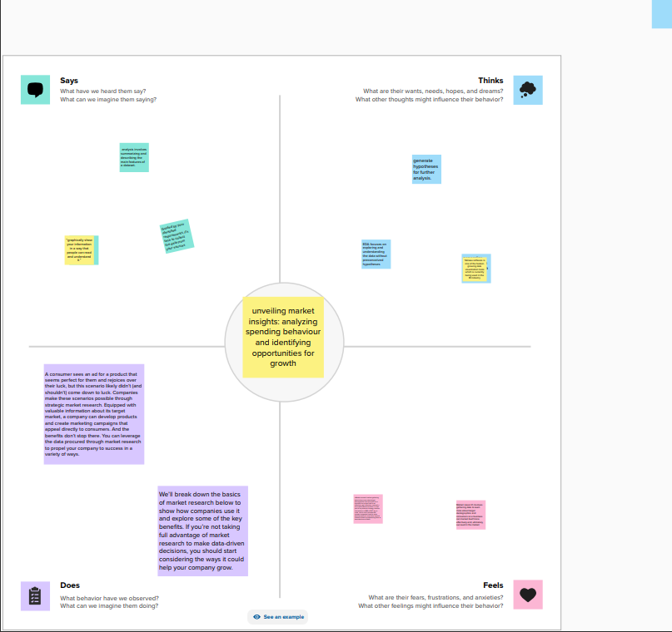

# Brainstorming Map

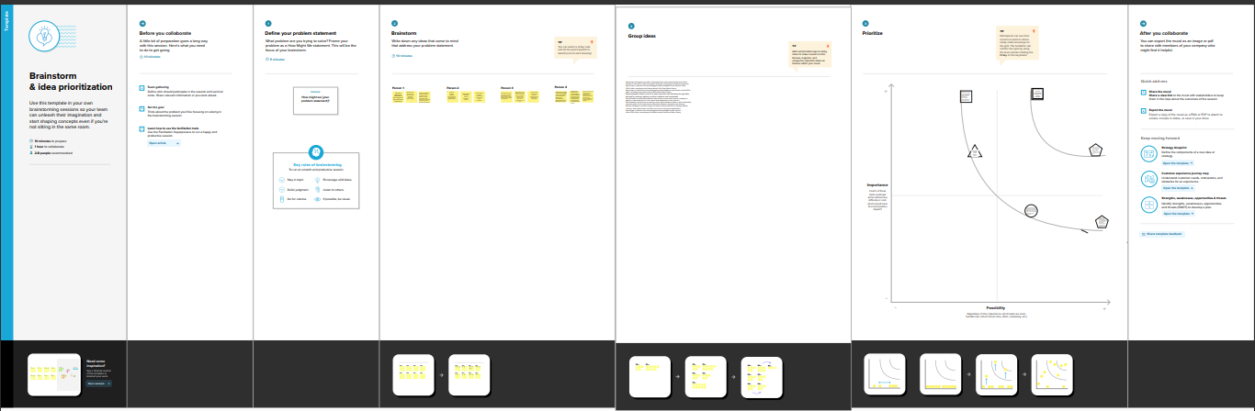

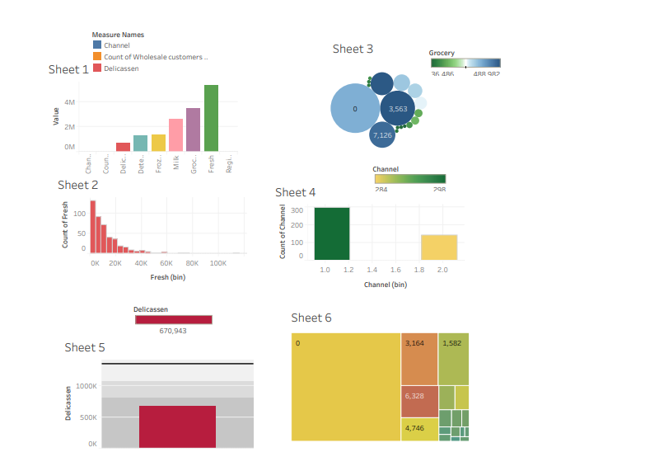

## ADVANTAGES

* **Quick calculation-** All the calculations on the tableau done by the backend, so it is relatively faster than any other tool.
* **Interactive dashboards**– Tableau dashboards are very interactive and easy to draw.
* **No manual calculation-**All the calculations done by the tableau only. There is no manual calculation but in some specific cases, we used calculated fields for calculation.

**A large amount of data-**Tableau can handle a large amount of data. Different types of visualization can be created with a large amount of data without impacting the performance of the dashboards

## DISADVANTAGES

* **High Cost-** tableau is a paid tool for visualization, and it is a reason why people are not using tableau so much.
* **Static and single value parameters-**Tableau’s parameters are static and always single value can be selected using a parameter. Whenever the data gets changed, these parameters need to be updated manually every time.
* **Limited Data Preprocessing-**Tableau is strictly a visualization tool. Tableau Desktop allows you to do very baic precessing.

# APPLICATIONS

There are many different engaging options, applications and alternatives of the tableau. The short placement creates the setup in no time as this tool promotes running start benefits. Tableau provides perceptive industry rate with clouds hosted editions and also on-premise paid annually. But, this module price depends on the number of users requirements. Now, let us study the different products of this software & its end-users

# CONCLUSION

Tableau is a software tool that provides a feature where you can transform your data into interactive dashboards. A combination of great analysis and storytelling, the data visualization tool removes noise from the background to help focus only on the essentials.

Tableau rests well with the security feature of the platform. The data that is shared across dashboards by various team members in the organization having its access- goes through a protected and safely entrusted environment.

# FUTURE SCOPE

Tableau offers interactive dashboards and reports less time backed by accurate data. All businesses are adopting Tableau and gaining actionable insights to make informed decisions. Big enterprises are integrating Tableau and getting the benefits. Demand for Tableau experts is increasing. Numerous coaching institutions, including SSDN Technologies, have been offering [**Tableau course in Gurgaon**](https://www.ssdntech.com/data-science/tableau-training-in-gurgaon). With these courses, it will be easier for you to become a master of the tableau platform.